Riley Snowe

CS 499

Southern New Hampshire University

05 June 2022

Journal

There are two trends I have found with one being the frontier supercomputer, and the other being groundbreaking research helping paramedics. Both trends are important to the field of computer science in different aspects, along with different used for citizens.

The frontier supercomputer is the fastest supercomputer in the world with 1.1 exaflops of performance. It has a threshold of a quintillion calculations per second, which is enormous compared to any other standard computer. The new supercomputer will allow for new research that has a lot of calculations that need to be performed. The supercomputer can help further the field of computer science by allowing for new calculations that further research of artificial intelligence. The supercomputer will not directly affect citizens but will help the workers trying to progress research. The supercomputer can help my field by allowing the research of new technologies which can further the use of developers.

The other trend is research that is aimed at helping paramedics. The research is a collection of models that can help predict where injuries may be, which allows for more accurate treatment that can be given by paramedics. This helps not only the workers, but also citizens as it can help them receive better treatment. The research does not directly affect me in terms of the field of computer science but can help if I were to have a position developing software for medical professionals.

The third artifact comes from my CS 340 class from our fourth week where we created a python file that tied into our MongoDB database. The artifact falls under the category of databases. In the assignment we had to create a python file that loaded the database information, created a method for creating information based on the user, and read information that is in the database. All changes have already been implemented to the code.

Reviewing the code and what could be changed, there were additional exceptions that could have been added. I implemented new exceptions for if the user did not input any data, along with new comments that further explain what is happening in each section.

Everything has been changed and nothing else needed from what I can see. The only concern that could be noted is security, which did not need to be further refined for this assignment. The only security concern is if there are any type of breaches that come from user input as nothing is validated beyond checking for input itself.

All changes have been added to GitHub, along with the rest of the artifacts. All initial artifacts are also added with before and after changes to the code.

Supercomputer: <https://www.rdworldonline.com/frontier-supercomputer-debuts-as-worlds-fastest-breaking-exascale-barrier/>

Research: https://www.rdworldonline.com/groundbreaking-research-could-help-paramedics-save-the-lives-of-pedestrian-casualties/

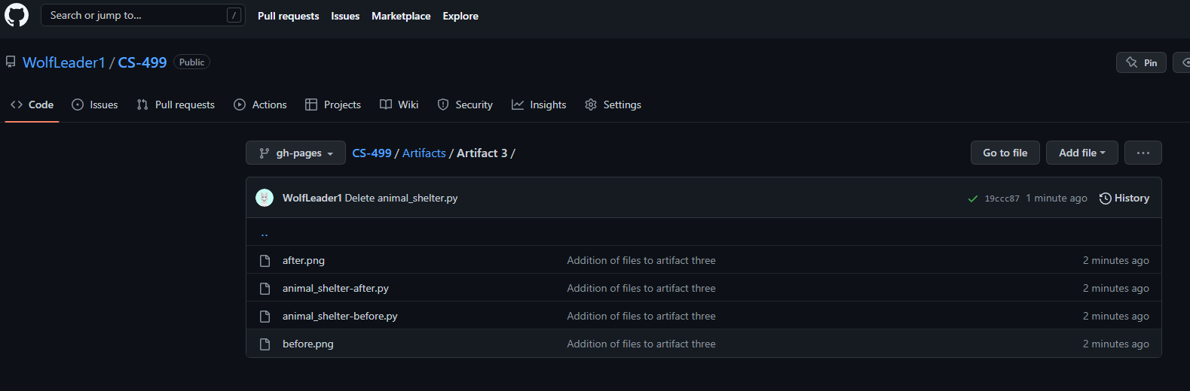

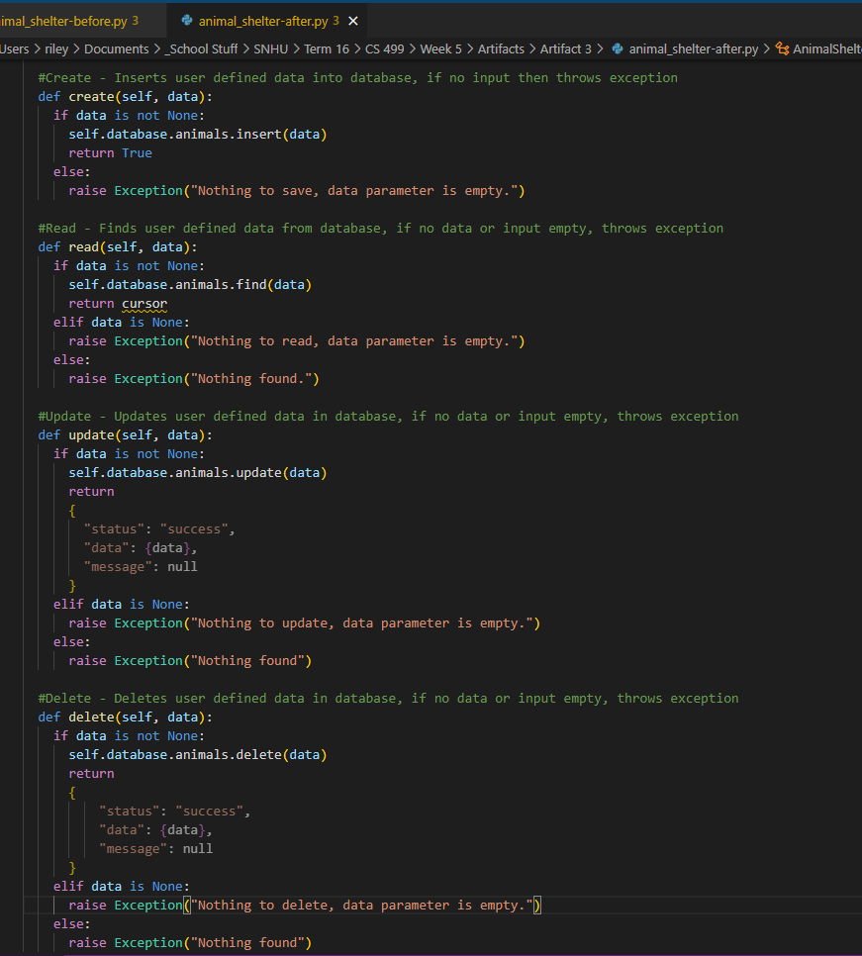Before Changes:

